DSCI 510 Project

Patricia Ferido

December 2021

- Motivation

Thousands of people go missing each year in California. At the same time, a substantial number of deceased individuals are found who are yet to be identified. The goal of this project is to utilize publicly available information on the web to contribute to descriptive analyses and facilitate matching between missing and unidentified persons. This project gathers data from the National Missing and Unidentified Persons System and the California Office of the Attorney General, compares the two populations, and creates a finder tool to facilitate matching missing persons to an unidentified person. On a personal level, this project combined my love of true crime and unsolved mysteries with newly acquired skills in web scraping and data analysis in Python. My ultimate hope is that the finder tool can be refined for public use by public officials or family members of missing persons looking for answers.

- Data

  - NaMUS Missing Persons Data
NaMUS is a national database and resource center for missing, unidentified, and unclaimed persons. The first data set I use is the missing persons from this site. It contains a public, searchable database with variables like sex, race, height, weight, hair color, eye color, age, clothing, special physical attributes like tattoos or piercings, last seen location, last seen date, pictures, and descriptions of the circumstances surrounding each case. This database can be accessed via a public API, returning a json file to be cleaned, parsed, and saved as a SQL database table.

  - NaMUS Unidentified Persons Data
The second data set I use is the unidentified persons data from the NaMUS. As expected, this is like the missing persons data except for unidentified persons. The key variables I use are race, sex, height, weight, age, hair color, eye color, image, special physical characteristics, found location, found date, and descriptions of circumstances surrounding recovery. Due to the varied nature of the discoveries, there is a large fraction of this data with missing or Null values. There was also a range given for weight, height, and age instead of a single value as these values are postmortem estimates. For example, there are cases in which a partial skeleton is found and therefore physical descriptors are unknown. This data is also accessed via a public API and the returned json file is cleaned, parsed, and saved into a clean SQL database table.

  - CA Office of the Attorney General Missing Persons Data
The final data set is a supplement to the missing persons with additional data from the California Office of the Attorney General. Unlike the other two data sources, this data is not accessible via an API and needed to be scraped directly from the website. In order to not hit the 50 result display maximum, the scraping of results is done by looping through a search by year of birth and scraping those results. While not as rich as the NaMUS data, this data set included key variables such as name, date of birth, sex, race, age, height, weight, hair color, eye color, physical markings and the circumstances of each case. These variables were saved into a SQL database table along with the other two data sets.

- Methods

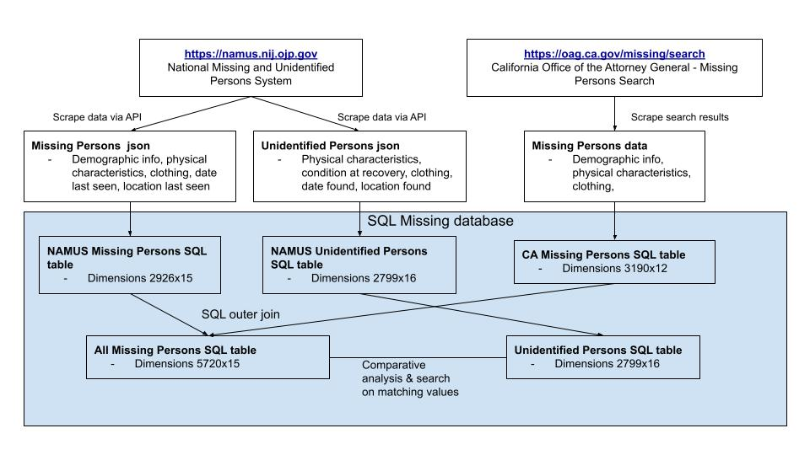
Fig 1. Diagram of Data Cleaning

As diagrammed above, after scraping the two data sets from NaMUS using an API and scraping the OAG missing data directly, these data were cleaned and saved as SQL database tables for ease of querying. Before analysis could be performed, the OAG missing persons data and the NaMUS missing persons data needed to be stacked and duplicates removed. This was performed by looking for matches on name, age within a 10 year buffer, and race between the two sources. While this is not a perfect match, accounting for age and race considers that there could be multiple people with the same name. Age between the two data sources is allowed to be at most 10 years different to allow for small differences in data reporting. Finally, sex is included into the match as another test to make sure the people are really duplicates. Duplicate people are then dropped from the OAG missing data set and the unique persons data set is stacked with the NaMUS missing data to create the full missing persons sample.

Additional data cleaning was done by creating pandas DataFrames from the SQL database tables. The race variable needed to be harmonized and cleaned as each case could include multiple values for race/ethnicity and different values existed between data sources. To make it easy to query and analyze the race distribution of the data, a clean race variable was created that categorized each person in the database as one of the following races: White, Black, Hispanic, Asian/Pacific Islander, American Indian/Alaska Native, Uncertain, Other, and Multiracial.

Finally, geographical characteristics were added to the data using the geopandas package to create maps of where missing persons were last seen and unidentified persons were found.

- Analysis

  - Comparison Analysis
To understand the underlying datasets, descriptive analysis was performed comparing the distributions of race, sex, age, and location of missing versus unidentified persons.

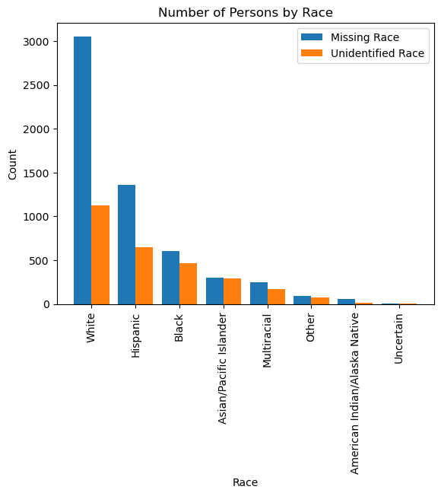

The figure above shows the count of each race for both data. Overall, we have more missing persons than we do unidentified persons across all categories. It seems like there are more white people who are missing relative to other races compared to the relative white people discovered, however this is difficult to ascertain using counts so I then graphed the percent distribution.

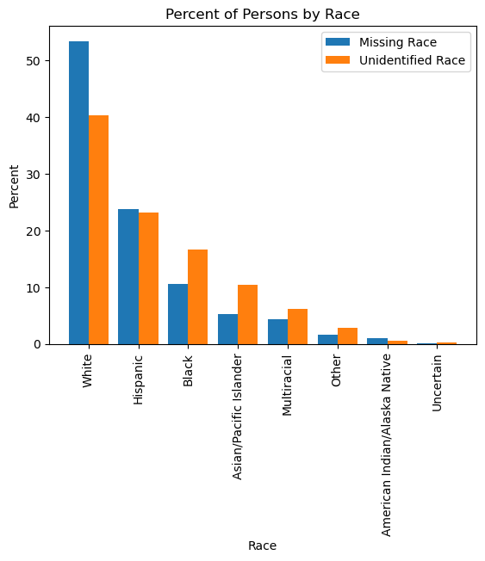

This percentage distribution is easier to compare and indeed shows that a higher fraction of the missing persons is White, while the unidentified population has higher relative fractions of Hispanic, Black, and Asian populations. There could be many drivers for this pattern including reporting practices and the nature of unidentified discovery. The unidentified population is more likely to be unhoused, which is a population with higher percentages of minorities. There could be potential cultural attitudes towards law enforcement that could prevent certain groups from reporting missing persons.

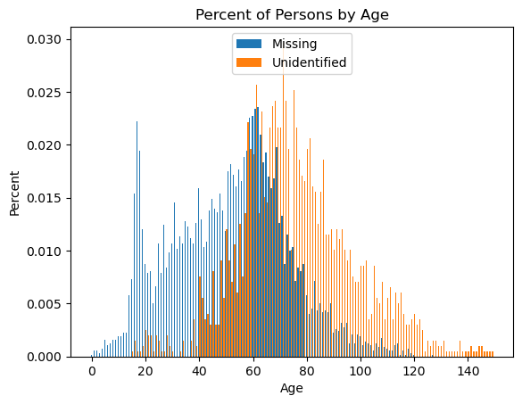

The age distributions of the two data sets seem quite different, with missing persons being younger and unidentified persons being older. This is expected given that unidentified persons tend to stay in the system for longer, which is why we see the right tail with individuals at 140 years of age. By definition, unidentified persons must be found after they have gone missing which could also explain the right shift. One interesting aspect of this chart is the large spike of missing persons in the late teens, early twenties age range. This could be expected given the volatility of this developmental period and typical age in which new adults are moving out of home and perhaps losing contact with their families.

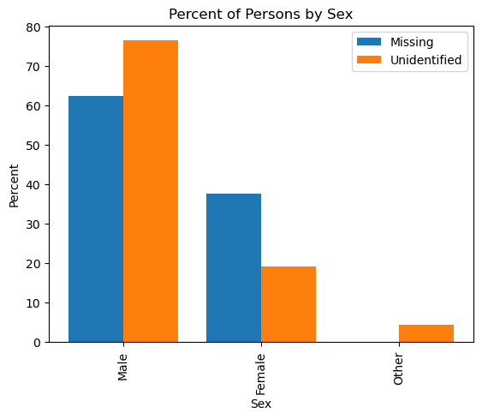
This chart shows the distribution of sex for both data sets. Both missing and unidentified populations are majority male. The unidentified population is 75% male and only 20% female. I am not sure what could be driving the much higher fraction of males in the unidentified population, but it is an interesting finding. Perhaps missing females are more likely to become housed and therefore less likely to be discovered by a member of the public upon death, while missing males are more likely to become unhoused and die in a location where they could be discovered. The roughly 3% in the ‘other’ category are those unidentified persons who were found in a state such that their biological sex could not be determined.

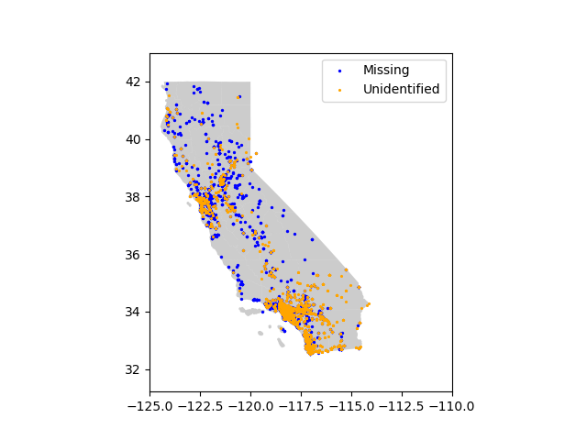

This map shows the differences between where missing persons are lost and unidentified persons are found. Missing persons’ cases seem to be evenly distributed around the state with a slight concentration in northern, central California. Unidentified persons however are more concentrated along the coast, in large cities, and in the southeastern desert area of the state. This would make sense as an area where bodies could be disposed of with little suspicion and less chance of discovery. It also makes sense that more bodies are discovered in high density areas such as cities.

  - Finder Tool
One of the main aims of this project was to create a finder tool that searches for potential matches for missing persons among the unidentified persons data. This was accomplished with a function that takes the name of a missing person as input and then queries the unidentified persons data for matches on the following characteristics:

- Race
- Sex
- Hair color
- Eye color
- Current age with an adjustable buffer to allow for differences as a function parameter
- Weight with an adjustable buffer as a function parameter
- Height with an adjustable buffer for differences as a function parameter
- Distance in miles between last seen location and found location

If any of the characteristics were missing in the unidentified persons database, they were not included in the match. For example, if only eye color was available in the unidentified persons data then a match required only a match on eye color.

This function can be called by running ‘python finder.py’ in the terminal with at least one argument being the name of the missing person you’d like to find matches for. The full list of arguments is as follows:

- Name
- Distance in miles within which to search, default to 50 miles
- Age year buffer, default to 10 years
- Height buffer, default to 20 pounds
- Weight buffer, default to 6 inches

The function outputs a list of potential matches to the console as well as a figure in the output folder showing the image of the missing person and images of all potential matches where available.

A few test queries are included in the full analysis program. Warning that the next few images include graphic images of deceased persons.

find('Abraham Volker',distance=100) – Search for Abraham Volker within 100 miles
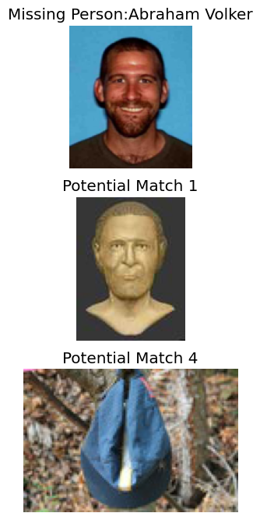

find('Eddie Gonzalez',distance=300) – Search for Eddie Gonzalez within 300 miles
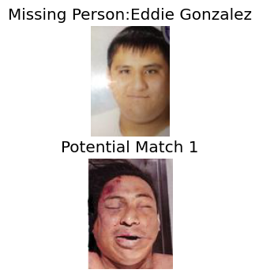
find('Anita Qvist') – Search for Anita Qvist with all defaults
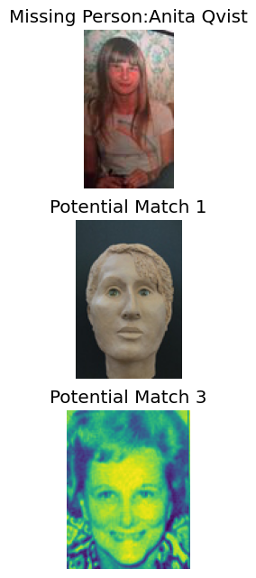

- Conclusions

The comparative analysis between unidentified and missing populations showed differences in every category. Unidentified persons were more likely to be minorities, more likely to be male, were older, and were concentrated in high density coastal cities and in desert country. These differences could point to potential gaps in resources needed to find missing persons. For example, the high rate of unidentified persons that are male could point to a gap in identifying females that may have been disconnected from their original communities but are existing in another sphere of society. The map also reveals some hot spots where unidentified bodies are discovered. Putting resources toward searching these areas, particularly searching the desert areas in the southeast part of the state could return fruitful results. Finally, the finder tool creates a fast and easy way to query the data and return potential matches that could then be compared visually. The process to find matches on the NaMUS site is very manual, so the finder tool simplifies the process and quickens the speed at which matches can be found and closure given to grieving families.

Next steps for this project would be to further clean up variables and take useful information out of the descriptive variables, like special physical characteristics and the circumstances surrounding the missing or found case. The finder tool could be further refined to utilize these data to get even more accurate matches. The use of the finder tool could be expanded to loop through every single person in the missing persons data set and rate the match, counting the number of matching characteristics and giving higher weight to characteristics difficult to match such as tattoos. Priority would be given to examining matches with particularly high ratings. Further work also needs to be done in presenting the results in a cleaner format beyond just a listing to the console and a print of all images. To be truly useful, the data would also need to be scraped on a regular basis to be up to date. The current work provides a strong basis for the rest of this work and was a fulfilling and challenging exercise in bringing together data, skills, and passion.

